GRACE FIRST BAPTIST CHURCH
2514 OBSERVATION DRIVE
San Antonio, Texas 78227
Rev Allen Ford, Pastor

LINWOOD F. RUSS AND BLANCHE A. RUSS MEMORIAL SCHOLARSHIP

2024 Second Year

APPLICATION

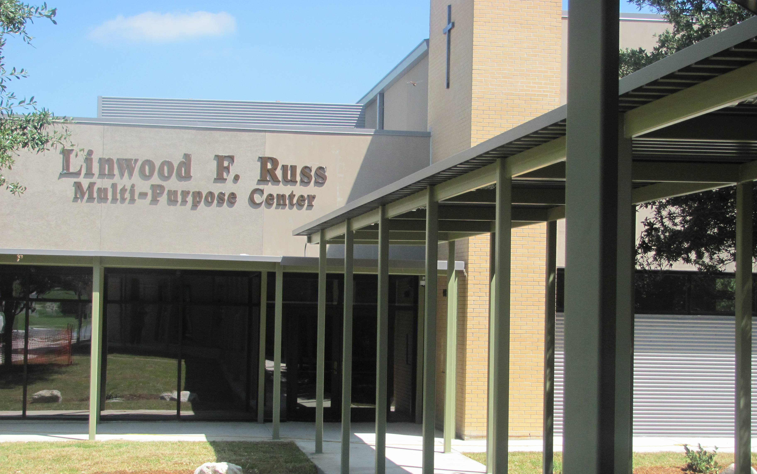

NOTE: Deadline for submission for 2nd year application is June 23, 2024

“The heart of the prudent getteth knowledge; and the ear of the wise seeketh knowledge”
Proverbs 18:15

GRACE FIRST BAPTIST CHURCH

LINWOOD F. RUSS AND BLANCHE A RUSS MEMORIAL SCHOLARSHIP
SECOND YEAR CONTINUATION (SOPHOMORE) APPLICATION

I. APPLICANT INFORMATION

A. ___________________________________________________________________________________________________________________
NAME DATE

B. ___________________________________________________________________________________________________________________
ADDRESS

C. __________________________________________________________________________________________________________________
CITY / STATE / ZIP

D. __________________________________________________________________________________________________________________
HOME PHONE CELL PHONE

E. ___________________________________________________________________________________________________________________
E-MAIL ADDRESS

F. ___________________________________________________________________________________________________________________
PARENT /GUARDIAN’S NAME

G. ___________________________________________________________________________________________________________________
PARENT /GUARDIAN’S HOME PHONE CELL PHONE

H. ___________________________________________________________________________________________________________________
PARENT/GUARDIAN’S E-MAIL ADDRESS

I. ____________________________________________________________________________________________________________________
PARENT/GUARDIAN’S HOME ADDRESS, IF DIFFERENT

II. CHURCH MEMBERSHIP

A. HAVE YOU MAINTAINED YOUR MEMBERSHIP AT GRACE FIRST BAPTIST CHURCH?
YES_______NO________

B. IS AT LEAST ONE PARENT OR GUARDIAN CURRENTLY A MEMBER OF GRACE FIRST BAPTIST
CHURCH? YES __________NO ___________

III. CHURCH INVOLVEMENT

A. WHILE AWAY IN COLLEGE, DO YOU ATTEND WORSHIP SERVICES REGULARLY? YES ___ NO ____

B. WHAT ACTIVITY OR AUXILIARY HAS HELPED YOU THE MOST IN YOUR RELIGIOUS
DEVELOPMENT? EXPLAIN.

_______________________________________________________________________________________________________________________________

_______________________________________________________________________________________________________________________________

_______________________________________________________________________________________________________________________________

IV. EDUCATIONAL INFORMATION

A. NAME OF THE COLLEGE/UNIVERSITY YOU CURRENTLY ATTEND? _________________________________

B. NAME OF INSTITUTION YOU PLAN TO ATTEND IN THE FALL_________________________________________

C. HAVE YOU REGISTERED FOR THE FALL SEMESTER? YES ______________________ NO _________________

V. CHRISTIAN FOUNDATION

1. Now that you are experiencing life away from home and from Grace First Baptist Church, how has the spiritual foundation you have received at GFBC assisted you in dealing with stressful situations? Explain_____________________________________________________________________________________________

______________________________________________________________________________________________________________________

____________________________________________________________________________________________________________

____________________________________________________________________________________________________________

2. How has your faith helped you handle the challenging experiences in college? Explain
______________________________________________________________________________________________________________________
______________________________________________________________________________________________________________________

______________________________________________________________________________________________________________________

3. Do you continue to study your Bible? Yes______ No_______. If yes, how has it helped you adjust to college life away from home and parents/guardian?

________________________________________________________________________________________

________________________________________________________________________________________

________________________________________________________________________________________

VI. FUTURE PROJECTIONS

A. After graduating from college, how will you reach back and contribute to your community and or to the youth of Grace First Baptist Church? Explain.

______________________________________________________________________________________________________________________

_____________________________________________________________________________________________________________________

_____________________________________________________________________________________________________________________

______________________________________________________________________________________________________________________

B. What are your long-term goals over the next five years with regards to your education and your spiritual development? Explain.
_____________________________________________________________________________________________________________________

_____________________________________________________________________________________________________________________

_____________________________________________________________________________________________________________________

____________________________________________________________________________________________________________________

REQUIRED DOCUMENTATION

SECOND YEAR APPLICANTS: To ensure that your college receives the funds in a timely manner, please provide the following documents ten (10) days before the semester begins. Place documents in a sealed envelope in the Scholarship mailbox in the church office. Contact Sister Mary Hall, Chairman of the Scholarship Committee at (210) 487-961 when your documents are ready and/or for additional arrangements if emailing or faxing is more appropriate.

The following documents MUST be provided before funds are disbursed.

1. Completed /signed application _____________

2. Official College Transcript (Fall/ Spring semester) _____________
Must have completed at least 24 semester credit hours with a GPA of 2.0 or greater

3. Fall Course Schedule _____________

4. Complete Attachment B _____________

Grace First Baptist Church
Linwood F. Russ and Blanche A. Russ Memorial Scholarship
AGREEMENT

This agreement is the final page of the application package. Please sign and date as appropriate below. Both signatures are required to be considered for this scholarship.

I ______________________________________________(student) have carefully read and understand ALL terms and conditions for a Linwood F. Russ Memorial Second Year (Sophomore) Scholarship.

I _____________________________________________ (parent/guardian) have worked closely with my son/ daughter during this educational experience and ensure compliance of application requirements.

_________________________________________________________________________Date________________
Signature of Applicant

________________________________________________________________________ Date________________
Signature of Parent or Guardian:

Attachment B:

Distribution of Scholarship Funds
Second Year (Sophomore) Recipients

Directions: To ensure timely and accurate distribution of funds please complete this form and provide the requested documents. Place your information in a sealed envelope in the scholarship mailbox and Contact Sister Mary Hall at 210-487-9761. Submit information ten (10) days before the semester begins.

______________________________
Date
_____________________________________________________________________________________________________
Name of Recipient

_____________________________________________________________________________________________________________________
College Student ID number (if required by college for application of funds)

Name of College, mailing address, specific department (for funds) Student must provide this information to ensure that funds are received in a timely manner.

________________________________________________________________________________________________

_________________________________________________________________________________________________

Second Year / Fall Semester include:
- Course schedule for fall semester (must be enrolled in at least 12 accredited hours)
- Official college transcript (must show a minimum GPA of 2.0 and completion of at least 24 credit hours)

Second Year / Spring Semester:

To ensure funds are received in a timely manner, submit the following documents ten days (10) before the semester begins.
- Fall Grades with a GPA of 2.0 or greater
- Fall completed grades should represent a completion of at least 12 semester credit hours.
- Spring course schedule
Documents are to be placed in the scholarship box or email to Sister Mary Hall at Maryhall100@outlook.com
If you should have questions or need special consideration call: 210-487-9761

